SEYCHELLES

Seychelles is located in the Indian Ocean about 1,600 kilometers (1,000 miles) east of Kenya. The nation is an archipelago of 115 tropical islands with two distinct collections of islands, some comprised of granite and others of coral. The Mahe Group consists of 42 granite islands, all within a 56-kilometer (35-mi.) radius of the main island of Mahe. These islands are rocky, and most have a narrow coastal stripe and a central range of hills rising as high as 914 meters (3,000 ft.). Mahe is the largest island--9,142 sq. km (55 sq. mi.)--and is the site of Victoria, the capital. The coral islands are flat with elevated coral reefs at different stages of formation. They have no fresh water; human life can be sustained on them only with difficulty
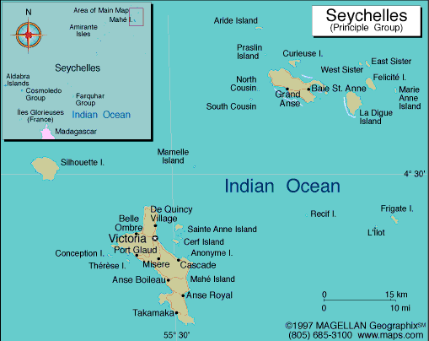

VISA REQUIREMENTS:

Visa issued (free of charge) to Indian nationals on arrival for a stay of 30 days.
Passenger should be holding valid passport, confirmed return air ticket, stay confirmation, sufficient foreign exchange.

HOW TO GET THERE:
INTERNATIONAL AIRPORT: Seychelles international airport

FLIGHTS INTO CAIRO:
Emirates (EK) & Kenya air (KQ) flies into Seychelles

CURRENCY:

Seychelles Rupee (SCR) = 100 cents. Notes are in denominations of SCR100, 50, 25 and 10. Coins are in denominations of SCR5 and 1, and 25, 10 and 5 cents.
Exchange facilities are available at the airport banks, which are open for all flight departures and arrivals. The following banks have branches in the Seychelles and will exchange traveller's cheques and foreign currency: Barclays Bank, Bank of Baroda, Banque Française Commerciale, Central Bank of Seychelles, Development Bank of Seychelles, Habib Bank Ltd, Nouvo Banq and Seychelles Savings Bank. Currency exchange receipts should be kept in order to facilitate re-exchange on departure
Credit/Debit Cards and ATMs:
American Express, MasterCard and Visa are widely accepted; Diners Club has more limited use. ATMs are available in Mahé and Praslin.
Traveller's Cheques
Accepted in most hotels, guest houses, restaurants and shops. To avoid additional exchange rate charges, travellers are advised to take traveller's cheques in US Dollars or Pounds Sterling.

GETTING AROUND:
Air: Air Seychelles operates multiple daily flights between Mahe and Praslin. Over two dozen flights vary in frequency from 15 minute to 2 hour intervals, depending on time of day.

Air Seychelles also operates once daily or several times per week between Mahe and the islands of Bird, Denis, Fregate, Desroches and Alphonse. Assumption Island and Coetivy can be reached by air charter.

Helicopter: Helicopter Seychelles provides shuttles between the main islands Mahe, Praslin and La Digue as well as charter flights to/from most of the inner islands. Helicopter Seychelles is the only scenic flight operator in the Seychelles. Depending on the timeframe, these scenic flights cover the main islands of Mahé, Praslin, La Digue and the surrounding smaller islands of Cousine, Félicité, Grande Seour, Curieuse and Cousin.

Boat: Cat Cocos is a high speed catamaran operating twice or thrice daily roundtrips between Mahe and Praslin. The sailing normally takes one hour.

Five or 6 roundtrips daily are made by schooner ferry between Praslin and La Digue. The crossing is 30 minutes and the schedule is timed to interconnect with Cat Cocos.
It is also possible to take small boats from Mahe direct to La Digue, although departures can be unreliable, there is limited wet weather cover and the journey takes about 3 hours (but that's cheaper than an Indian Ocean Island cruise!)

Car: Having a car is really a good idea. It is easier to find a good view point. You can only rent on Mahé and Praslin. Keep in mind that renters must be at least 21, have a valid driver's license, and have at least three years of driving experience.
Taxis are also popular means of transportation for both short trips and day rental and can be obtained almost anywhere.

Bus: Seychelles Public Transport Corporation (SPTC) runs daily bus services on the islands of Praslin and Mahe from morning to evening on nearly every available road on the island. The bus usually passes by every 15 minutes.

BUSINESS:
Seychelles office hours are Monday to Friday 0800hrs-1600hrs.Most government offices and some private businesses close on Saturdays and remain closed on Sundays and also on public holidays.

CLIMATE:
Seychelles is hot and humid, with an average yearly temperature of 84°F (29°C), and average sea temperature rarely dropping below 81°F (27°C). However, the heat is usually mitigated by refreshing sea breezes, especially by the beaches. The cooler season in Seychelles is during the southeast monsoon season (late May to September) and the warmer season is during northwest monsoon (March to May). Northwest monsoon season tends to be hot and rainy while the southeast monsoon season is usually drier and cooler.

Best Time to Visit:
As the Seychelles islands are blessed with a year-long warm, tropical climate, it’s always a good time to visit, although different times of year may be better suited to your particular interests.

The table below summarises the best times to visit Seychelles for different types of activities.
Activity | Period
Bird-watching | April (breeding season), May - September (nesting of Sooty Terns) October (migration)
Diving | March – May / September - November
Fishing | October - April
Hiking/Walks & Trails | May - September
Sailing | Year-round
Snorkelling | Year-round
Surfing/Windsurfing | May - September

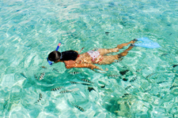

CLOTHING:
Tropical lightweights, with rainwear advisable during the rainy season. Sun hats and sunglasses essential all year round

TIME:
Seychelles is 1 hrs 30 mins behind us.

ELECTRICITY:
Electricity in Seychelles is 240 Volts, alternating at 50 cycles per second. If you travel to Seychelles with a device that does not accept 240 Volts at 50 Hertz, you will need a voltage converter.

Outlets in Seychelles generally accept 1 type of plug:
Two parallel flat pins with ground pin

If your appliances plug has a different shape, you may need a plug adapter.

DAILING CODE:
+248

TIPS:
Most service providers already include a service charge of 5% - 10%. Tipping is not obligatory in the Seychelles; however, any extra change is greatly appreciated.

LANGUAGE:
There are three official languages in Seychelles: Creole (a lilting, French-based patois), English and French. Many Seychellois also speak fluent Italian or German.

SHOPPING
The best place for shopping is Victoria, the capital, and more specifically the market at the city center. There are also a few outlets on the island, Praslin, but few shopping areas on the other islands. Larger hotels have boutiques but shopping in Seychelles is not one of the major attractions.
While visiting, be sure to buy the classic and traditional Seychelles souvenir, the coco-de-mer, or the 'nut of the sea,' a nut from trees native to the islands in the Seychelles - but this requires an export license. Other locally made souvenirs, although not as unique, can be purchased like sea shell and pearl jewelry, textiles, and straw hats, in addition to needlework & crochet, paintings by local artists, and woodwork.
FOOD:
Seychellois cuisine has been greatly influenced by the islands' rich cultures. Creole cooking, varied seafood dishes, coconuts and curries are the most popular. The main product of the country, fish, is cooked in a variety of ways. Especially the red snapper is very tasty and well known to visitors.
Cheapest food: Collect coconuts on the beach and learn how to open their terrible cover (not the shell, that's easy; they have a thick cover of natural fibers; to open it: hit the coconut very strongly many times on the edges, sooner or later the fibers break up).

DRINK
Seychelles offers a fantastic nightlife scene that caters to tourists. The active nightlife is mostly located around the larger hotels and in addition to theatres; cinemas and discos, there are numerous fun and trendy restaurants.
If you enjoy a good beer you must try the local Seybrew beer, it tastes similar to a light Bavarian style beer and is a must to get you through those balmy days. You can save yourself a packet buying the beer from stores on the side of the road like the locals do rather than from hotels. Dark Takamaka Rum on the beach under the stars is the best way to end a day on the Seychelles.

ACCOMMODATION:
The Seychelles are not tolerant of backpackers turning up at the airport without accommodation booked. Most accommodations, however, are relatively expensive and some islands have only one hotel. In fact, some of the islands aren't even permanently inhabited and accommodation can be found on fewer than 10. Your best bet for a budget bed is renting an apartment or bungalow, which can be rented at very reasonable rates. Also keep in mind that hotel prices greatly increase and accommodation can be hard to find during the peak seasons from December to January and July to August. Holidays such as Easter can also get very busy.

For those looking to live like the rich and famous, try the North Island Seychelles Hotel, a glamorous resort frequently visited by celebrities like Brad Pitt, Jennifer Aniston, Pierce Brosnan, Paul McCartney, and Heather Mills to name a few, that charges no less than $1500 per night. North island was recently rated “Top 10 Travel Destinations” in 2007 by Forbes Magazine, number one of “the best Hotels on Earth” by Harpers Bazaar, and “No 1 in the World, Best of the Best” by Condé Nast Traveller.

For those on a budget or student travelers, there are a few comfortable and very affordable hostels in Seychelles

SAFETY
Seychelles has a low level of crime; however, it is advisable to take routine precautions. Try to avoid any dark bylanes and be careful not to leave your bag unattended on sparsely occupied beaches; most locals are poor and would love to get their hands on a wad of dollars or euros. Swimming alone on isolated beaches is not advisable.

HEALTH:
Chikungunya virus is a disease spread by mosquitos, and causes flu-like symptoms. It is increasing in concern and although it is rare to die from it, the joint pain it causes can last for months. Insect repellent can help deter mosquitos but not much else can be done as a precaution.

Tap water is safe to drink in most areas of the Seychelles, but water quality is variable in undeveloped areas. It is recommended to drink bottled water only and to avoid bodies of fresh water like lakes, rivers, ponds, etc.

GENERAL INFORMATION:
- The Best way to see Seychelles is to do 3 nts at one of the Islands and the balance 3 nts at another Island, since the connections from India fit the 6 nts / 7 days schedule. Mahe has the International Airport.
- On Mahe Island the Berjaya Beau Vallon Bay is a good 4 star Hotel and has a Casino. The Coral Strand is a nice Hotel too and houses the “Mahek” & the “Hilltop restaurant “the ONLY 2 Indian Restaurant in Mahe !! Mahe is normally the Island that attracts the maximum number of Visitors.
- Praslin Island is a growing place and has some of the Best Beaches in the World. Anse Lazio is rated as one of the 5 Best Beaches in the World. Mahe to Praslin takes 15 mins by Helicopter and 45 mins by Ferry.
- The Coco De Mer Hotel located in the South of Praslin is good Hotel. It has daily shuttle service to Anse Lazio which takes 30 mins.
- There are NO Indian Restaurants on the Island. Normally from Monday to Friday one can enjoy the Hotel Entertainment, Friday and Saturday is Disco Night and Wednesday to Sunday the Pubs are open.
- The Casino is located in the North East and the Best Creole Restaurant is also in the same area.
- La Digue is the Third Island that visitors go to in the Seychelles. It is extremely quiet and not much recommended for the Indian Clientele unless they want to be left alone. There is essentially no Nightlife at all here and everything is deserted by 6 pm. One can travel from Praslin to La Digue by Boat ONLY.
- There are many Hotels / Chalets on the Island which may not be necessarily on the Beach but are very good value for money and have all the amenities.

CITIES:

MAHE
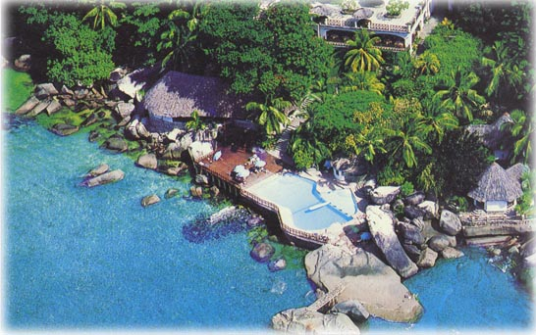

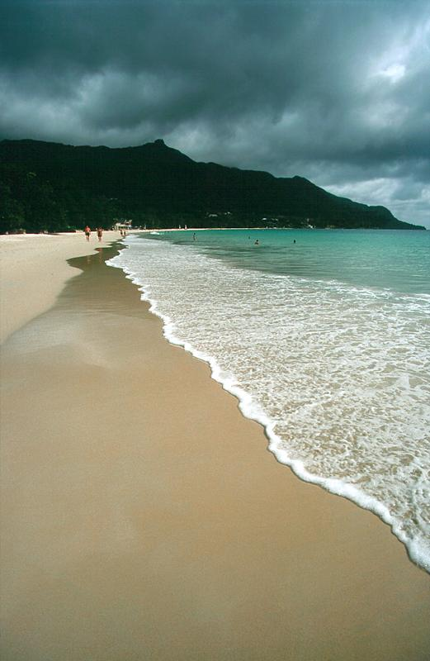

The island of Mahe is about 17 miles long and only two to five miles wide. The highest point is Morne Seychellois, at around 2,969 feet. A chain of mountains runs along the center of Mahe, with only a narrow ring of land around the island which is relatively flat. Most of the residents of Mahe live on this coastal strip. The mountainous interior of Mahe is not only steep, but also thick with forests and large boulders made of granite. The most remote beaches are on the south and west coasts of Mahe, while the east coast is more developed. The north coast has the best of both worlds: beautiful beaches plus great restaurants and lodging establishments. There is a main highway that follows the coastal contours of the island, hugging the coast around almost the entire island. There are some smaller roads that cut across the island, so it's easier to get from east to west. Most tourist accommodations in the Seychelles are on Mahe.

Beau Vallon
Beau Vallon have gorgeous white sands, and is found on the Northwest part of Mahe. It was once the best and most popular beach in the Seychelles, but over the years tourists have discovered the more private and natural beaches of the smaller islands of the Seychelles. Now Beau Vallon is a very quiet beach, and the water is deeper here than most beaches. Snorkelling and diving are good off Beau Vallon, and swimming is great.
There are lots of places to stay in Beau Vallon, from small guest cottages to larger lodging choices.

Victoria
This largest city of the Seychelles was named after Queen Victoria during British colonial rule. Victoria is the largest settlement on Mahe, and also the capital of the Republic of Seychelles. However, even though it's the national capital, the feel of Victoria is a smaller, quieter town rather than a bustling city. About one third of Seychellois live in Victoria, whose population is 23,300. There's a hospital, a Barclays Bank and some smaller banks, a pharmacy, a tourist office, and soem travel agencies in town as well as book shops, the Central Post Office, a movie theater, supermarket, and some internet cafes.
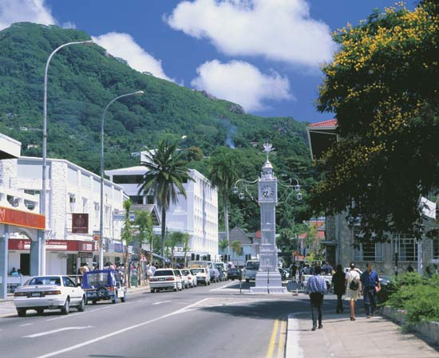
There are small guest houses in and around Victoria, as well as some good restaurants.

North Mahe

North Mahe is where most of the local residents of Mahe Island live, and it is also where most of the island's develoment has taken place. The island has a severe housing shortage, so the government is reclaiming land in this part of Mahe, to be used for housing developments. Nevertheless, there are gorgeous beaches, plus Morne Seychellois National Park.

Praslin
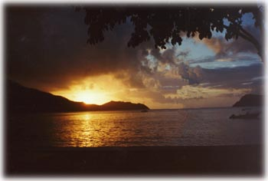

A short 15 minute plane flight, or 3-hour boat ride from Mahe, lies the wonderful island of Praslin. This, the second largest island with it’s 5,000 inhabitants is unique in the world, some of the plants here grow no where else within the whole world, even within the Seychelles. The island is like it’s big sister Mahe, a granite island, but somewhat less mountainous, it’s highest point being only 370 meters. Cars exist on the island, and the roads are good, but you are assured of peace and quiet. A bicycle can be hired instead of a car, and offers the tourist the possibility to explore virtually everywhere. The hotels offer a luxury standard in quiet and peaceful surroundings, with some bungalows directly on the beach.

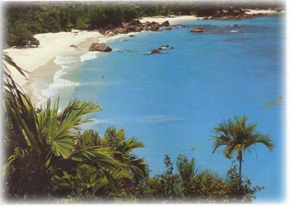
Praslin is the perfect tropical island, since it's not over-developed but has some tourism activity for visitors. The topography and environment are lush, green, and picture-perfect tropical island vegeation and scenery. The overall flavor of the island's culture is relaxed and peaceful. It's made of granite and has a spine of mountains running down its center. Praslin is about seven and a half miles long by three miles wide, which makes it the second-largest island of the Seychelles Islands. Most people visit Praslin to see Valle de Mai, which is a preserved area of forest where coco de mer palms are abundant. This is a major attraction of the Seychelles Islands because there only a few places in the world where this particular palm grows wild. The other main attraction of Praslin of course is the beaches.

The beaches on Praslin are somewhat longer and wider than those on Mahe, and they offer wonderful swimming and snorkelling. Praslin gives rise to some of the most beautiful beaches within the whole of the Seychelles. Amongst the best beaches are those of Anse Lazio, Anse Georgette, Anse Kerlan and Anse Volbert. The majority of the inhabitants live in one of the two villages; Baie Ste. Anne in the east and Grand Anse village in the
south. A trip to these villages should be included in everybody’s stay

Valle de Mai
Valle de Mai is on the list of World Heritage Sites because of the rare coco de mer palm tree. This type of palm grows in the wild only here and on nearby Curieuse Island. Your entry fee to the park goes towards preserving the area, which is a gem-like slice of paradise that everone from artists to wildlife enthusiasts consider to be one of the best spots on earth for experiencing tropical perfection. There's a black parrot that lives only here on Praslin, whose habitat is preserved by the park's existence.
Visitors to Valle de Mai should keep to the trails, of which there are three. You can enjoy the park for hours on end, via these trails, one of which takes several hours to traverse.

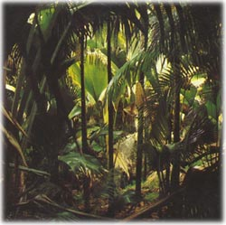
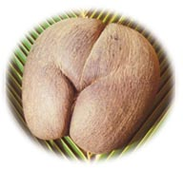

La Digue island
La Digue is situated a short distance from Praslin, but is unreachable by plane, instead a short boat ride from Praslin to La Digue is required, lasting only 20 minutes or so.

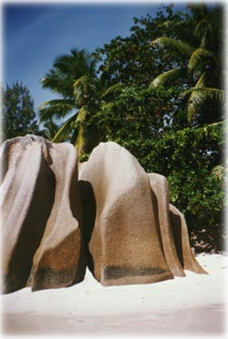

Immediately after stepping off the boat one notices the oxcarts, the taxis of La Digue. Cars are restricted on the island, with only a few in existence. Oxcart is the main method of transport, but bicycles can be hired allowing the tourist easy transport to the more difficult to reach places.

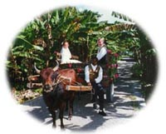
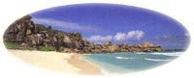
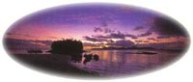

La Digue is the fourth largest and third most populated of the islands within the Seychelles, with over 2,000 inhabitants. Several hotels exist on the island, providing comfortable accommodation, the most popular being La Digue Island Lodge. In addition there are several guesthouses offering simpler accommodation. It is also possible to visit the island on a day trip from Praslin

La Digue is most famous for its beautiful landscape, offering unique rock formations reaching down to the sea. No where else within the Seychelles are such wonders to be seen, the ancient granite rocks worn away by old father time, leaving breath taking structures for the eye to marvel at. La Digue is surrounded by beautiful white sand beaches, spectacular coves where one can find deserted beaches with no other tourists beside yourself. The simple beauty and charm has made the island into a favourite for film producers and photographers.

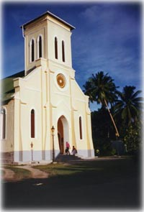
On the island is a wonderful small church, called ‘The Lady of our Assumption’, which is about to celebrate its first century. It is located not far from the Port, just south of La Digue Island Lodge. A little further down a working plantation exists, here you can watch the gathering and processing of coconuts, or examine the vanilla plantation.

For the more adventurous, who don’t want to spend the whole holiday on the beach, climb tothe top of the mountain at the heart of the island, it offers a wonderful view of the island. At the ends of the roads, the follower is left with just a footpath to follow, leading them to the next cove of discovery, the next deserted beach, or losing them in the tropical forests and the undergrowth, leading the follower through the wonderful botanical world. Whatever, you will be happy that you took the time and followed the trails.
Whatever you see and do on La Digue, you will be assured of a warm welcome from the local people. The life style is slow and relaxed, there are no problems or stress here, so just put your feet up, lie back and relax, life can be so wonderful.

Be sure to bring your camera and lots of films to this most wonderful of all islands, you will be in love from the moment you step foot on its shores. Should your stay be too short, you can always come back next time, and you will

Excursions from Mahe

Full Day Cruise of Mahe Island's Southern Coast
Cruise from Victoria along the east coast to the beautiful south and experience the route of the pirates 3 centuries ago. When we reach Anse Royale, the site of the Royal Spice Garden, the catamarran will ply along the reef to give you the best that the South coast has to offer, with views that have remained practically unchanged for centuries. Sail along the beach of Anse Forbans, frequented by pirates to careen their ship and to stock up on food and water. It is also believed that certain treasures are buried here. The majestic boulder of Cap Mason is believed to have been the place where witch doctors used to perform their macabre rituals. The unspoilt coves of Anse Marie Louise, Capucin, Petit Boileau and Pointe Police are now considered to be the last nesting beaches of the hawksbill turtles, a species threatened with extinction. A snorkeling stop is also scheduled to view the underwater world in all its splendour. Before lunch, the guests are allowed to stretch their legs on the white sandy beach. A barbeque lunch is served on board in the beautiful bay of Takamaka or Anse Soleil, depending on the condition ofthe sea. Our return cruise starts just after lunch, this time further from the coast for us to cast our lines for a bit of

Full Day Trail and Sail
An opportunity to experience a thrilling adventure trekking and cruising back on our catamarran "Catalina". Starting from 'Danzilles', the palm-fringed trail along the deserted northwest coast is bordered with granite boulders. Our experienced guide points out the flora and fauna along the way. The 1.5 hour walk ends at 'Anse Major', where our catamarran "Catalina" is moored in the sheltered bay. After boarding from the pristine beach by dinghy, the day's excursion continues with a cruise to the Bay Ternay marine park, stopping at some beautiful snorkelling sites, where guests not wishing to swim can spend time feeding the fish or sunbathing on the spacious deck

Full Day Reef Safari: Starting with a transfer to Victoria's marina to board our luxury catamaran, Catalina, for the trip to the middle of the harbour, where we stop to feed the fish and allow you to explore the fascinating underwater world by snorkeling and swimming with the fishes. A delicious lunch is served on board, a mouth watering buffet prepared in traditional creole style. After lunch, there is ample time for marine enthusiasts to explore the reefs through the windows of our semi-submersible or for those more geared to relaxation, take a swim a simply take a snooze on the beach of Cerf Island. For a perfect ending ofthe day, a "petit punch de Iles" is served on board before heading back to the Marine Charter and to your hotel.

Sunset Classic Cruise
Follow the sun going down behind Silhouette Island for a romantic sunset cruise from Victoria. Tropical Cocktails will be offered during the cruise, accompanied by beautiful Creole music performed by our talented musicians. By the time the sun has disappeared within the depths of the horizon, our staff on board will be getting ready to serve dinner under the starlit sky. Dinner by candlelight to the sound of the waves lapping against the hull of the catamaran. After swaying to the rhythm of the sega beat, we start cruising back to Mahe under the watchful eye of the Southern Cross.

Sunset Cruises with "Bazaar Labrin:
Join our cruise, which starts in Victoria, and sail to the bay of Beau Vallon to visit the "Bazaar Labrin", a colourful open market along the beach every Wednesday evening. The open market offers an array of cultural and culinary activities, frequented by both visitors and local residents alike. We board the catamaran just before the sun goes down beyond the horizon for the Sunset Cocktail, with Creole melodies pulsating in the background. At the first sign of darkness over the ocean, our cooks will invite you savor the 'gestustation' of authentic Creole cuisine. We will then sail back slowly to Victoria along the North East coast the catamaran drops anchor at the marina in Victoria, for the transfer to your hotel.

Full Day Discovery Tour of Mahe Island:
Highly recommended as an ideal introduction to the Seychelles' way of life. The tour begins with a transfer from the hotel for a stop in the colonial centre of "the world's smallest capital", Victoria. Highlights to visit are the court buildings, museum, post office, Little Ben clock-tower [twin of the one outside London's Victoria Station]. A turn around the corner takes one to the only set of traffic lights on Mahe Island, next to the 'Codevar' building where local crafts, including the renowned Kreol or [Creole Gold] are on display for sale. A walk across Albert Street leads one to the focal point of the town, its colourful market where stalls of fresh fish, tropical fruits & vegetables, herbs & spices, are displayed in an abundance of fragances. This is followed by a drive across the Sans Soucis mountain pass, with a photo stop at the historical Mission Lodge, en-route to the quaint hillside Creole restaurant for lunch in the midst of the rolling hills of Takamaka, south Mahe. After lunch, the tour continues around the southern tip of the island to the restored colonial plantation of 'Jardin du Roi', which is steeped in the short history of the Creoles and the Georges family,whose family tree carries a supposed link to Louis XVII of France. A cold drink of home-grown fruit welcomes tourists, before they tour the surrounding plantation of vegetables, exotic fruits, herbs and spices.
The rest of the afternoon is for relaxation, with a stop at the Craft Village on the way back to the hotel, at about
16h00.

Full Day Praslin & La Digue Tour: Praslin, the second largest island in Seychelles, lies approximately 1.5 hours by boat or 15 minutes by air from Mahe. Tourers will be able to visit the
Vallee-de-Mai, the only place on earth where the giant Coco-de-Mer nut grows in its natural state - a walk along the tended paths of this primeval forest, listening to the trill of the rare Black Parrot, transports one to the beginning of time; giving credence to the legends of this World Heritage Site being the original Garden of Eden. The tour includes a visit to the famous Anse Lazio beach, before the 30-minute crossing to La Digue, during which one has a good chance to spot dolphins. Visitors to La Digue island will marvel at the timeless atmosphere, with the comforts of the 21st century blending smoothly with the tranquility of yesteryear, where life is lived mainly at the pace of the oxen. Transfer from the jetty is by oxcart to L'Union Estate for a tour of the copra sheds, the giant land tortoises and the recently refurbished colonial plantation house, location of the film “Goodbye Emmanuelle”. The tour of La Digue resumes by 'camion', an open-sided truck with canopy, stopping at Anse Source d’Argent, one of the most spectacular beaches in the world, allowing you ample time to photograph the impressive granite rock formations. This 11-hour tour, which sometimes starts on La Digue, is an attractive opportunity to visit the highlights of both islands in one-day

Excursions from Praslin

Half Day Vallee-de-Mai Guided Tour:
Starting with a coach transfer from the hotel, this half-day excursion is dedicated exclusively to the renowned Vallee-de-Mai Nature Reserve, a UNESCO World Heritage Site. This extraordinary primeval forest, known as the Garden of Eden, is the unique habitat in the universe where the Coco-de-Mer palm grows in its natural state. The Vallee-de-Mai is also home to one of the world’s rarest birds, the Black Parrot.

Full Day Vallee-de-Mai / Anse Lazio Tour:
Starting with a coach transfer from the hotel, this full-day excursion is dedicated to the renowned World Heritage Site, the Vallee-de-Mai Nature Reserve, and relaxation on one of the world's highest ranking beaches, Anse Lazio. This extraordinary primeval forest, known as the Garden of Eden, is the unique habitat in the universe where the Coco-de-Mer palm grows in its natural state. The Vallee-de-Mai is also home to one of the world’s rarest birds, the Black Parrot. Lunch is not included in the price, although a discount is offered to tourists presenting a copy of our excursion voucher to the Bon Bon Plume restaurant at Anse Lazio.The afternoon is at leisure at Anse Lazio, voted amongst the Top 10 in the world, ending with the transfer back to the hotel at 16h00.

Full Day Excursion to Cousin, Curieuse & Saint-Pierre islands,
This tour starts with a transfer to Baie Ste Anne jetty for the 2-km crossing at 09h00 to the Special Reserve of Cousin island. Our cruiser moors off-shore and tourists are taken to the island on a Reserve boat to prevent accidental introduction of pests to the island. It is highly recommended that tourists come prepared to wrap their belongings in water-proof bags, and that they respect the safety regulations of donning life jackets and remaining seated until the craft is beached. A warden leads the tour of the island with its abundance of species and habitats, from the coast with its protective mangroves, to the wetlands which attract dragonflies, moorhens, caecilans & Seychelles terrapins; on to the rejuvenated forest on the hill plateau which provides ideal nesting sites for large populations of shearwaters and bridled terns amongst its endemic trees - mapou (Pisonia grandis) , Indian mulberry (Morinda citrifolia) and bwa sousouri (Ochrosia oppositifolia). Endemic birds found o (Nectarinia dussumieri), Fody (Foudia seychellarum) , Blue Pigeon (Alectroenas pulcherrima) and the Warbler (Acrocephalus seychellensis) . The tour continues with a 30-minute boat ride to Curieuse Island, where a splendid BBQ lunch is served on the beach. Curieuse island has a large population of giant tortoises, some can be seen next to the natural pond on the coast, whilst the majority range across the island freely, and can sometimes be tracked by their vociferate calls of intimate congress. The tour ends with an hour's snorkelling off the tiny island of St. Pierre. For the un-initiated, our crew is on hand with lightweight snorkelling vests to ensure that no-one misses the chance to view the abundant marine life.

Full Day La Digue Tour
This tour starts from your hotel, with a transfer to Baie Ste Anne Jetty for the 30-minute crossing to La Digue Jetty, for onward transfer by ox-cart to l”Union Estate for a tour of the copra sheds, the giant land tortoises and the recently refurbished colonial plantation house, location of the film “Goodbye Emmanuel”. The tour of La Digue resumes by 'camion', an open-sided truck with canopy, stopping at Anse Source d'Argent, one of the most spectacular beaches in the world, allowing you ample time to photograph the impressive granite rock formations which are unique to the Seychelles; to swim or simply to soak in the sun. A Creole lunch is arranged at a local restaurant at around 13h15, followed by a beach siesta before returning to Praslin island on the 16h30 schooner.

Full Day Boat & Bike Independent Tour of La Digue Island: This tour is ideal for the adventurous seeking to explore La Digue island on their own, and includes return coach transfers the hotel and Praslin Jetty, a ferry crossing at 09h00 to La Digue, where tourists are greeted by our island representative for a short briefing on the most popular sites, best routes and lunch venues, before she hands over a guide map and the bicycles for the day's adventure. The boat trip back to Praslin departs at 16h30, the end of a perfect day - most guests with another day to spare choose to return to the magic of La Digue Island.

Full Day Excursion to Aride Island, with Guide, Lunch and Coach/Boat Transfers:
This tour also starts with a transfer to Baie Ste Anne jetty for the 9-km crossing at 09h00 to the Special Reserve of Aride island, home of over a million pairs of seabirds. Visitors are welcomed to the island by the Reserve Warden, who will guide them to the summit of this crescentshaped island, which is only 134 metres above sea-level, for a better view of the soaring birds. Aride Island has 11 species of sea-birds and boasts the world's largest colonies of both the Lesser Noddy (Anous stolidus) and Roseate Tern (Sterna dougalli). It is the only place in granitic Seychelles where the red-tailed Tropic Bird (Phaeton rubricauda) is still breeding.
Among the other seabirds to be seen are the Fairy Tern (Gygis alba) , Black Noddy (Anous tenuirostris) , Bridled Tern (Sterna anaethetus) , Sooty Tern (S. Ffuscata) , white-tailed Tropic Bird (Phaeton lepturus) , wedge-tailed Shearwater (Puffinus pacificus) , Audubon Shearwater (P. iherminieri) , Lesser Frigate Bird (Fregata ariel) and Greater Frigate Bird (F. minor). Its ma moorhen (Gallinula chloropus seychellarum). A small number of hawksbill turtles (Eretmochelys imbricata) nest on the beach. At least two species of skink occur on the island, in numbers large enough to threaten the sea birds' eggs and young chicks. Aride Island is a success story since its purchase by the Royal Society for Nature Conservation (UK) in 1973. Visitors interested in the environment, and bird-watchers in particular, will not want to miss this opportunity to view the abundant flora and fauna, although it should be noted that trips to Aride island are very much dependent on the weather and tide patterns - the best months for planning a visit are October to May. A delectable Creole BBQ lunch on the beach is included in our price.

Full Day Sister & Coco Islands - a deserted island experience,
These tiny granitic ‘gems’ are located to the north of La Digue and are accessible by a 30-minute motorboat ride from Praslin. Sister Island boasts one of the finest beaches in Seychelles, and is un-inhabited, excepting for the warden and his wife. The reef on the western side is ideal for snorkelling, while the island's prolific coconut plantation lends itself well to exploration. A typical Creole barbeque is served under the shelter of an old ‘boat house’ by the beach. The tour's highlight is the afternoon's snorkelling off Coco Island, an experience second to none. Coco Island is a small granitic outcrop sporting a few palm trees - its real treasure lies in the surrounding depths, which is often compared to a living aquarium.
For the un-initiated, our crew is on hand with lightweight snorkelling vests to ensure that no-one misses this unique experience to view the underwater world.

